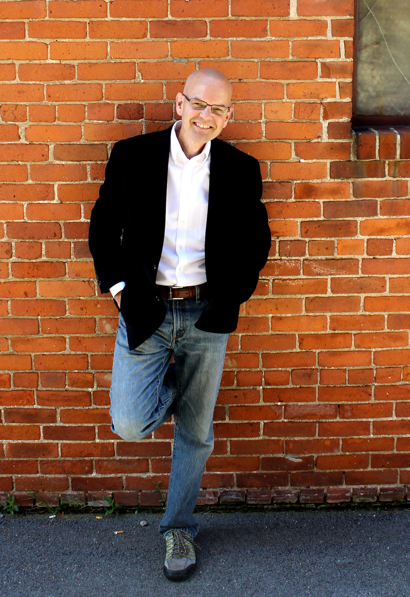
Mike grew up in Detroit and considered himself “pro-choice” until shortly after coming to faith in Christ in 1984, when the church he attended showed the pro-life film, The Silent Scream. Upon being confronted with the reality of abortion, Mike became deeply convicted and prayed for God’s forgiveness, offering himself as a voice for the unborn.
Mike served as a pastor for 23 years before joining the staff of Life Training Institute in 2012, where he serves as the Midwest Director of Training. Mike has a burden to awaken the church to the plight of mothers facing unplanned pregnancies and to the little ones they carry. He travels extensively throughout the United States speaking as the keynote at banquets and conferences and addresses thousands of students each year on high school and university campuses. Mike is a gifted and much sought after communicator who brings a pastor’s heart to the often emotional and divisive issue of abortion in a way that is both gracious and compelling. He and his wife, Barb, have five children including a daughter they adopted from Guatemala. Mike and his family currently reside in Celina, Ohio.

